Installation Steps

Download the Evaluation Edition from – <https://dev.mysql.com/downloads/installer/>

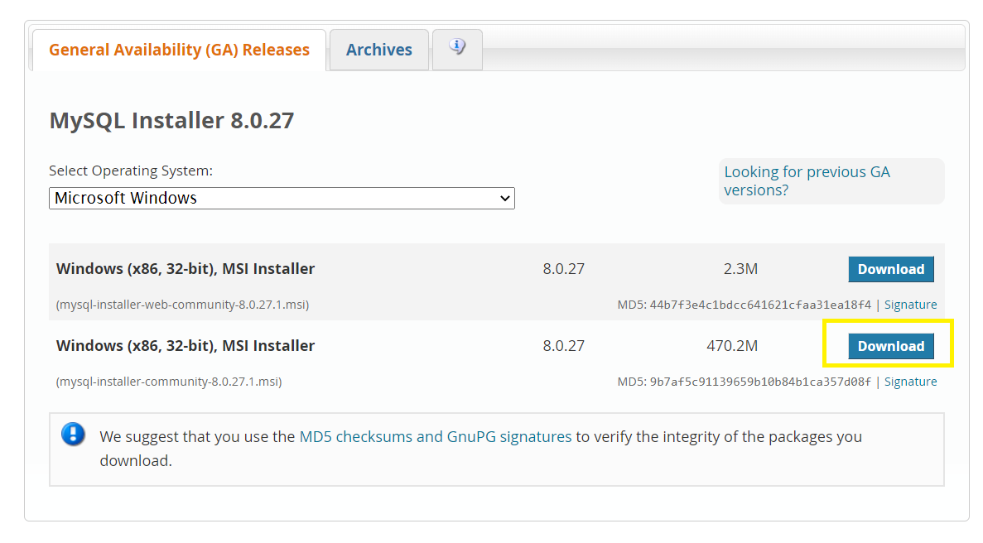

**Step 1-** Click on download 450.7 M

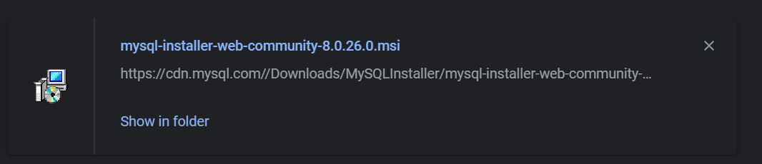

**Step 2-**

Double-click on **“**[mysql-installer-web-community-8.0.26.0.msi](https://cdn.mysql.com/Downloads/MySQLInstaller/mysql-installer-web-community-8.0.26.0.msi)”

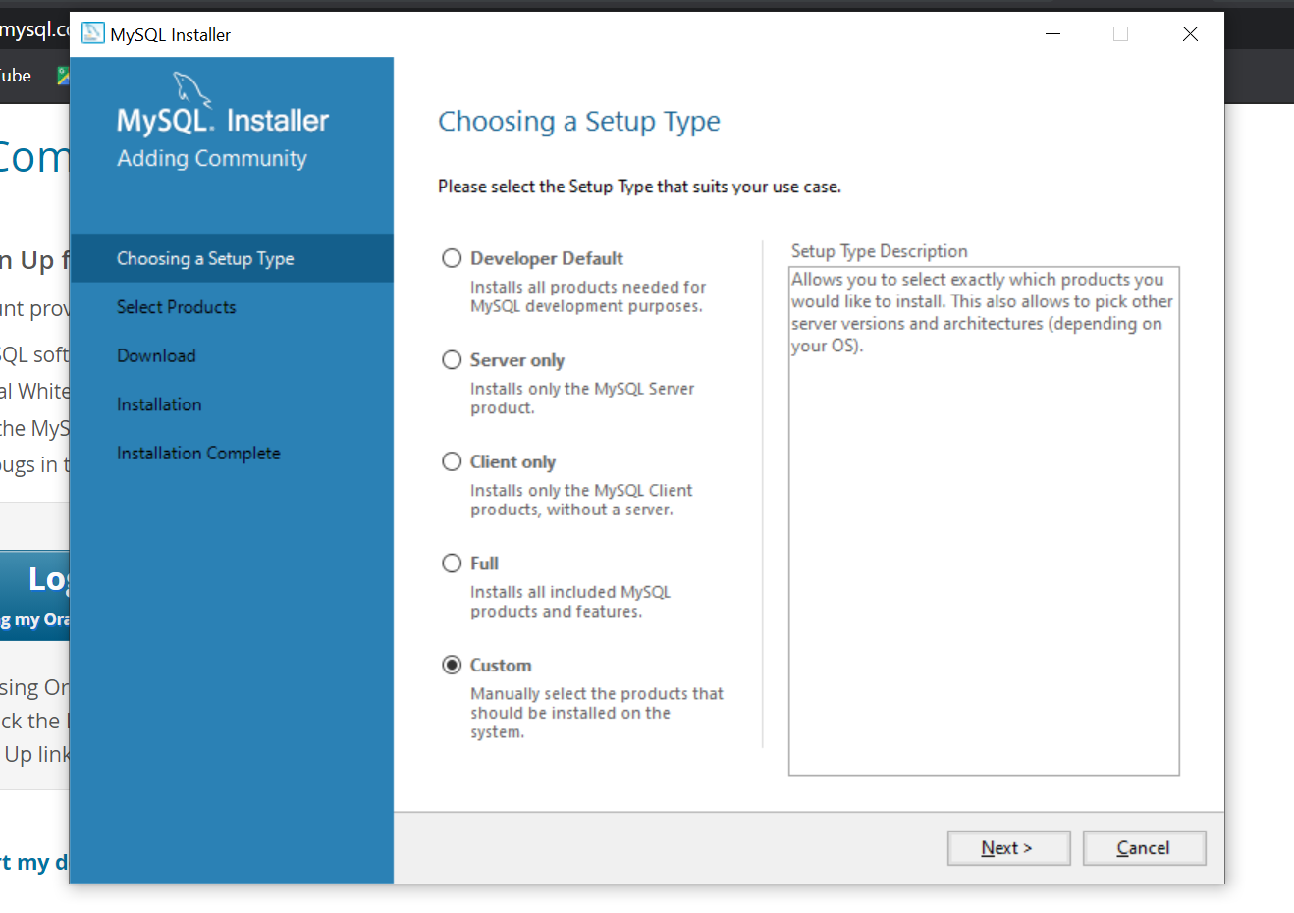

**Step 3-** Select custom and click on next

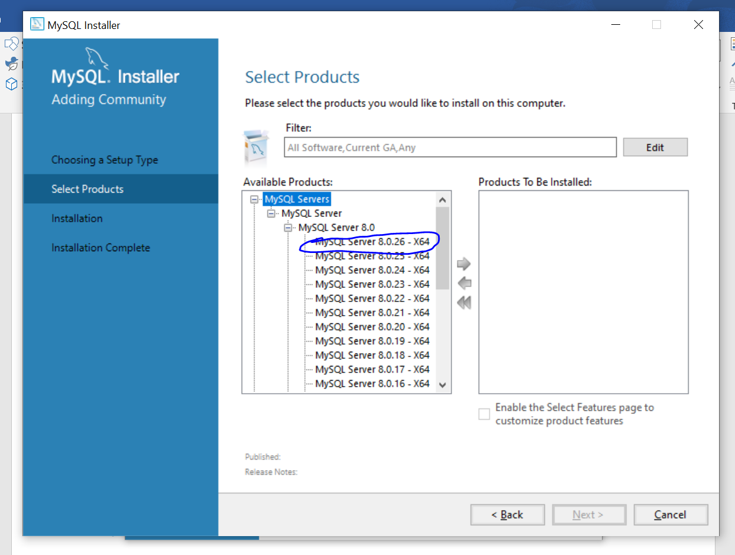

**Step 4-** Select MySQL Servers > MySQL Server > MySQL Server 8.0 and select MySQL Server8.0.26 and drag it to the right side of box by clicking on arrow

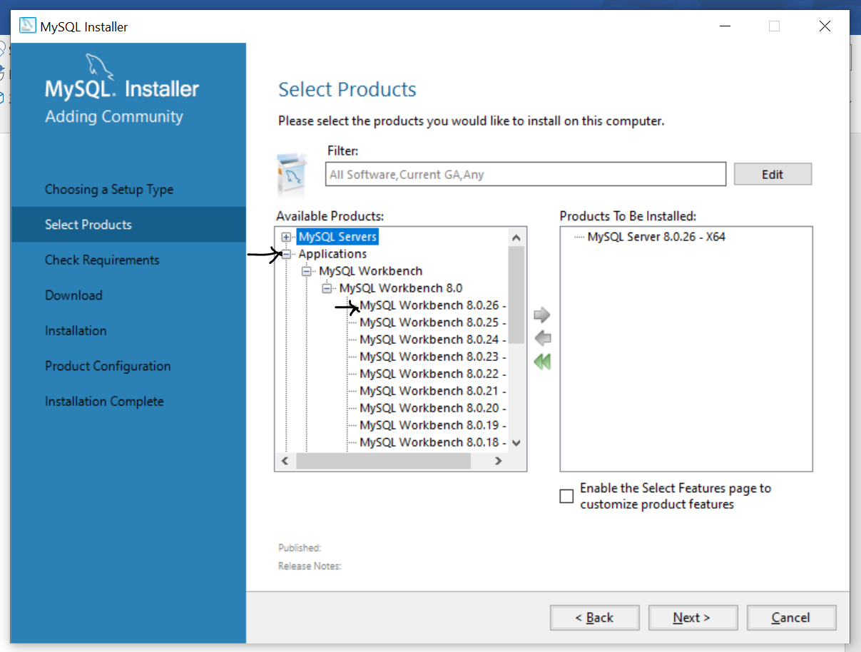

**Step 5-** After MySQL Servers Select Applications > MySQL Workbench > MySQL Workbench 8.0 and select MySQL Workbench 8.0.26, drag it to right side of box by clicking on arrow

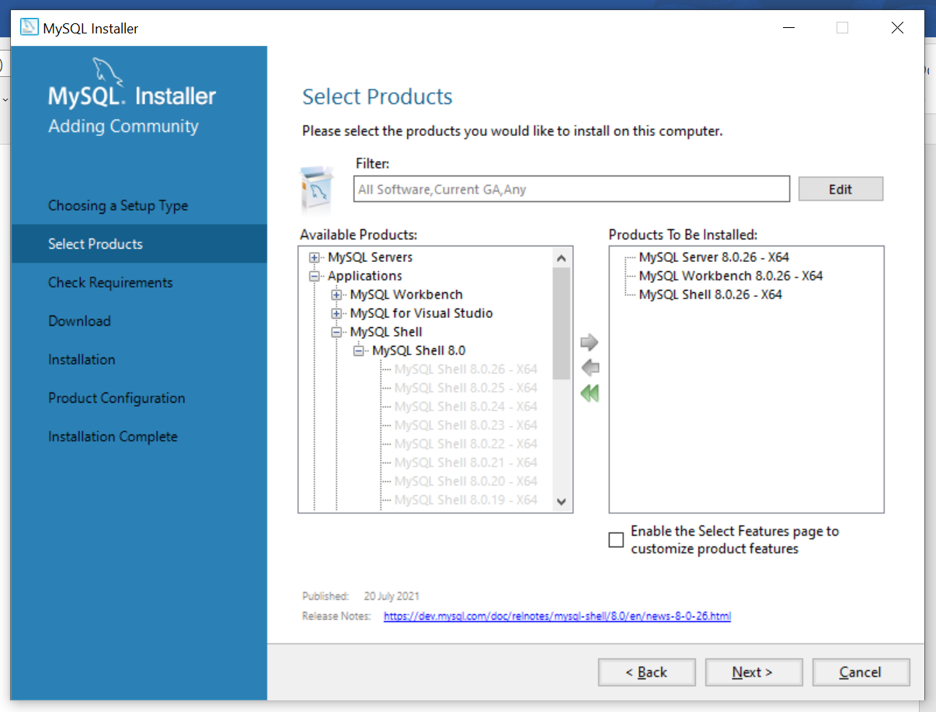

**Step 6-** Select Applications > MySQL Shell > MySQL Shell 8.0 & select MySQL Shell 8.0.26 and drag it by clicking on arrow

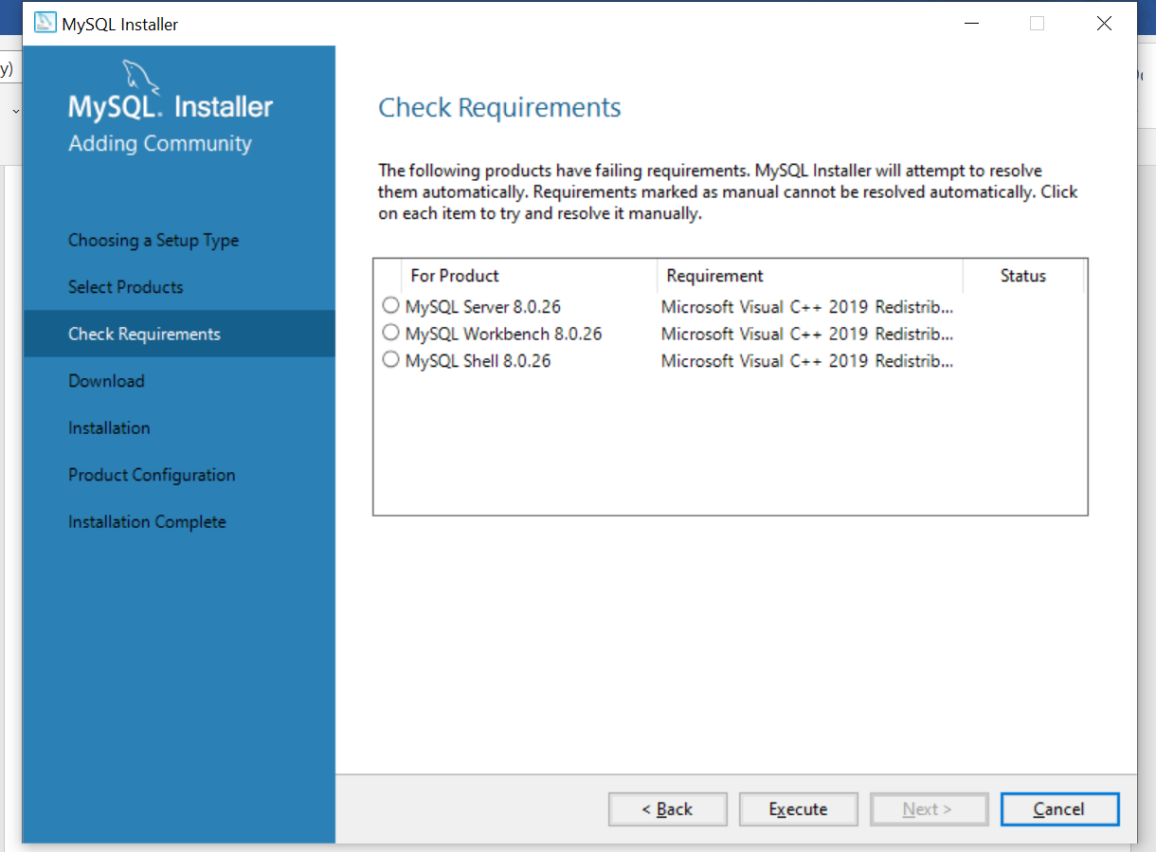

**Step 7-** Click on Execute

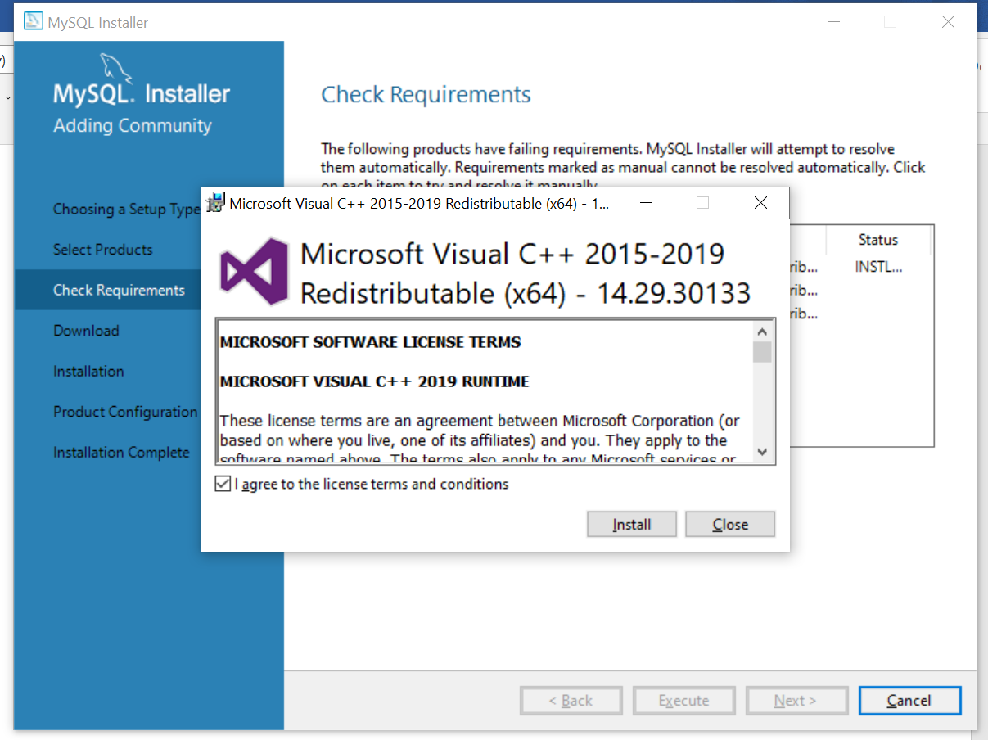

**Step 8-**Select the checkbox to accept the license option and click Install

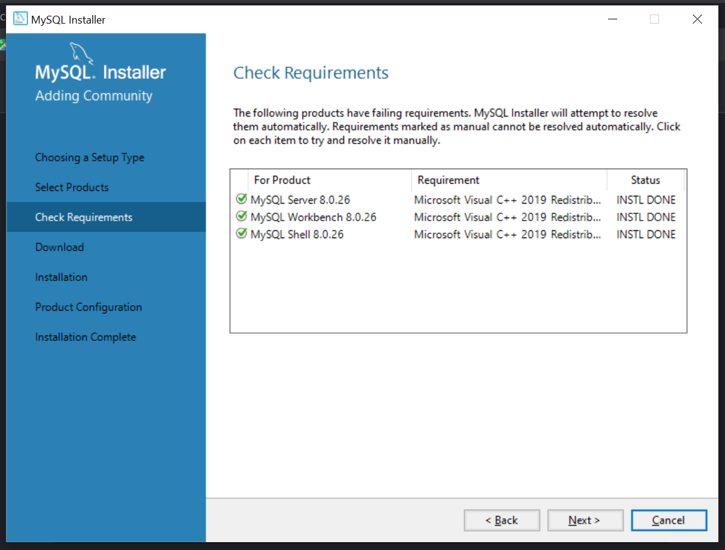

**Step 9-**Click on Next

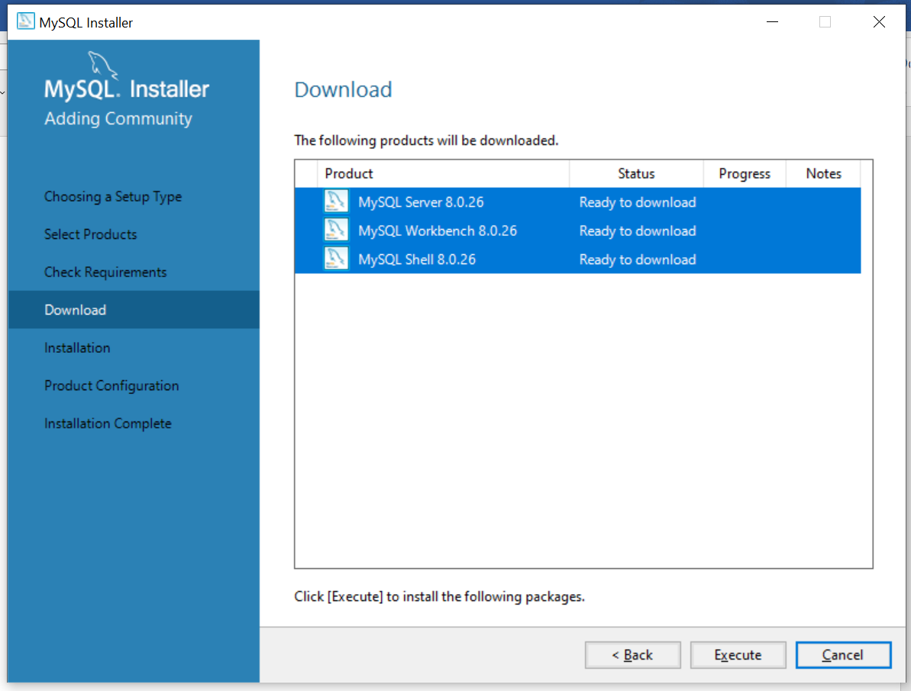

**Step 10-**Click on Execute

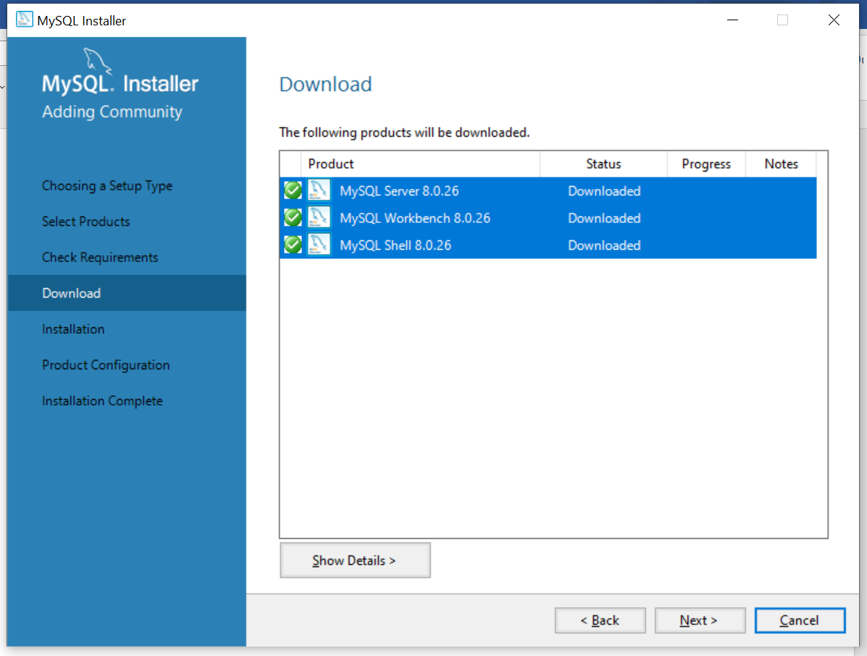

**Step 11-** Click on Next

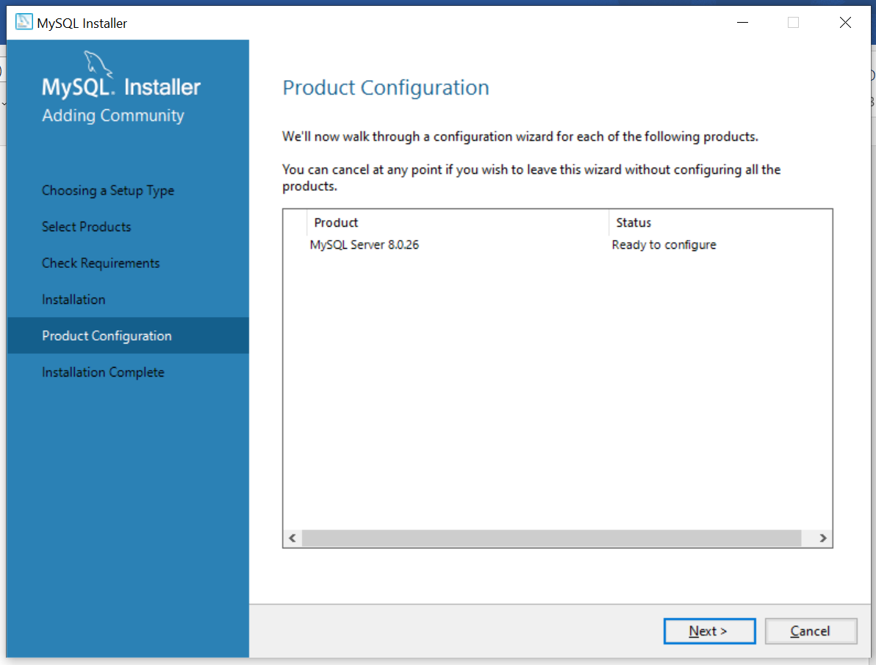

**Step 12-** Click on Next

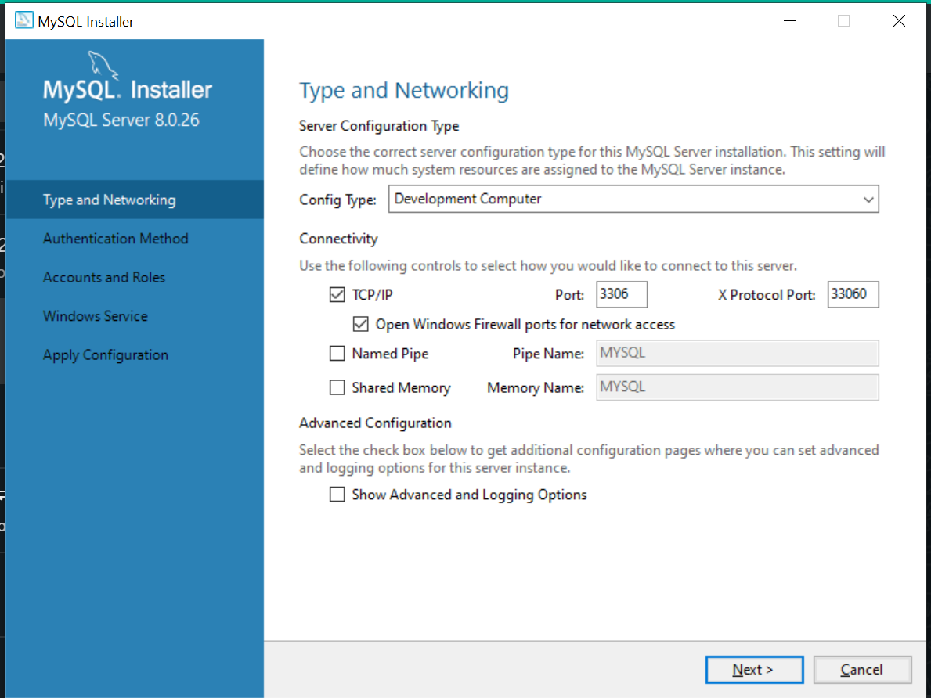

**Step 13-** As you can see the type and networking keep it default and click on Next

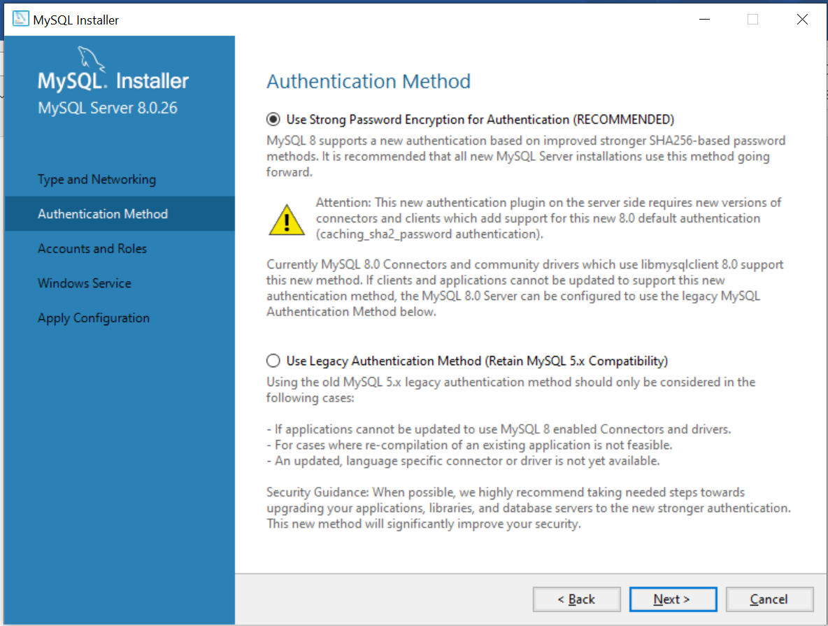

**Step 14-** Go to Next

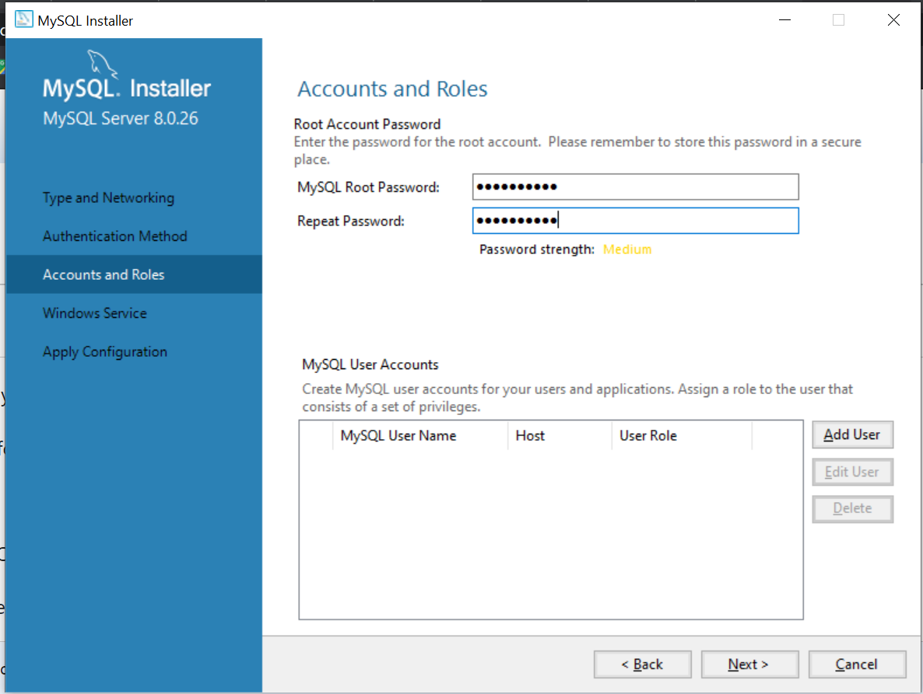

**Step 15-** Set a root password and click on next

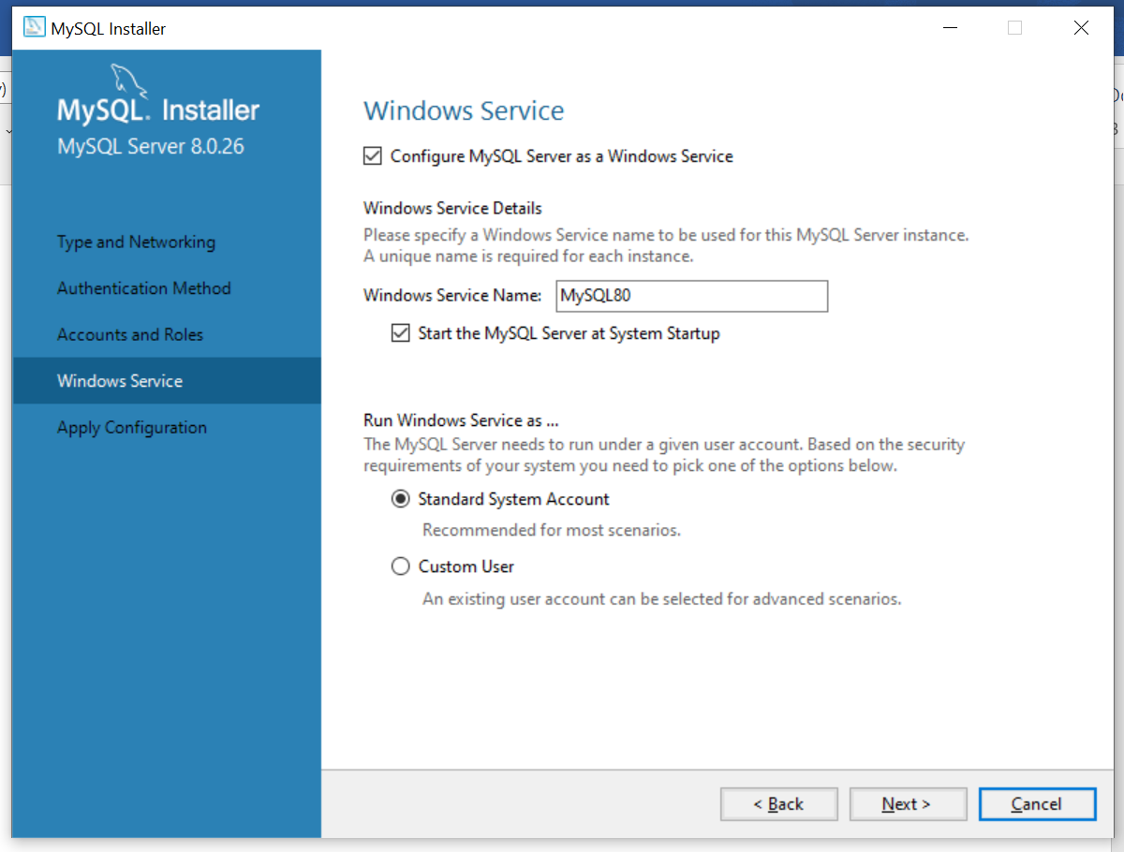

**Step 16-** Keep the default and click on Next

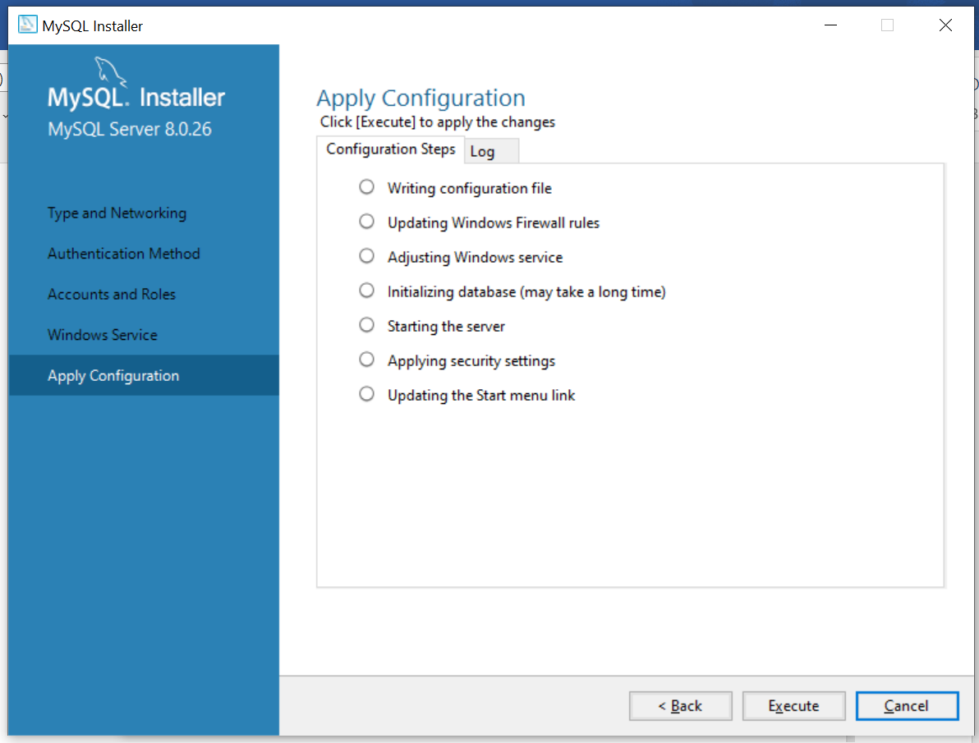

**Step 17-** This is the apply configuration click on execute to apply all of them

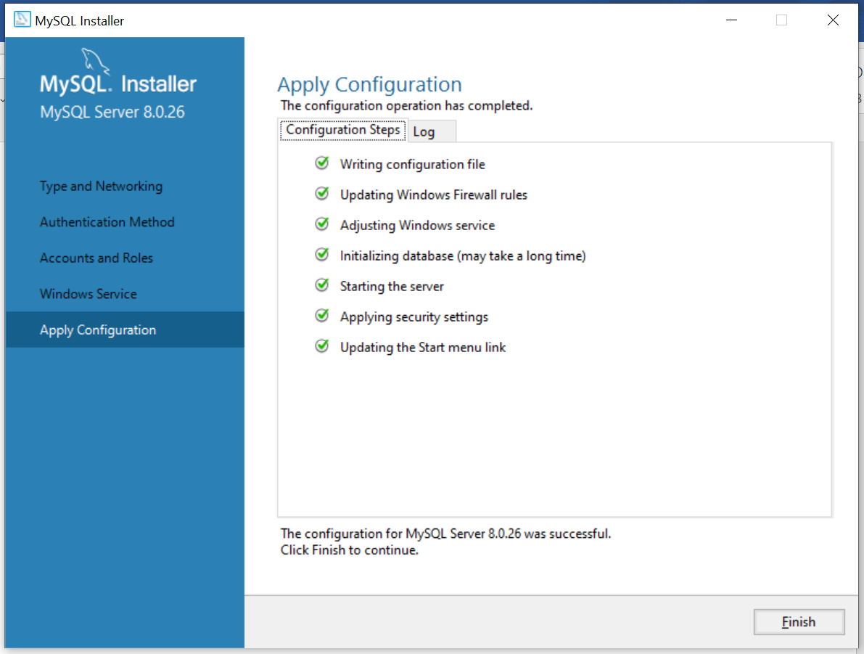

**Step 18-** Click on Finish

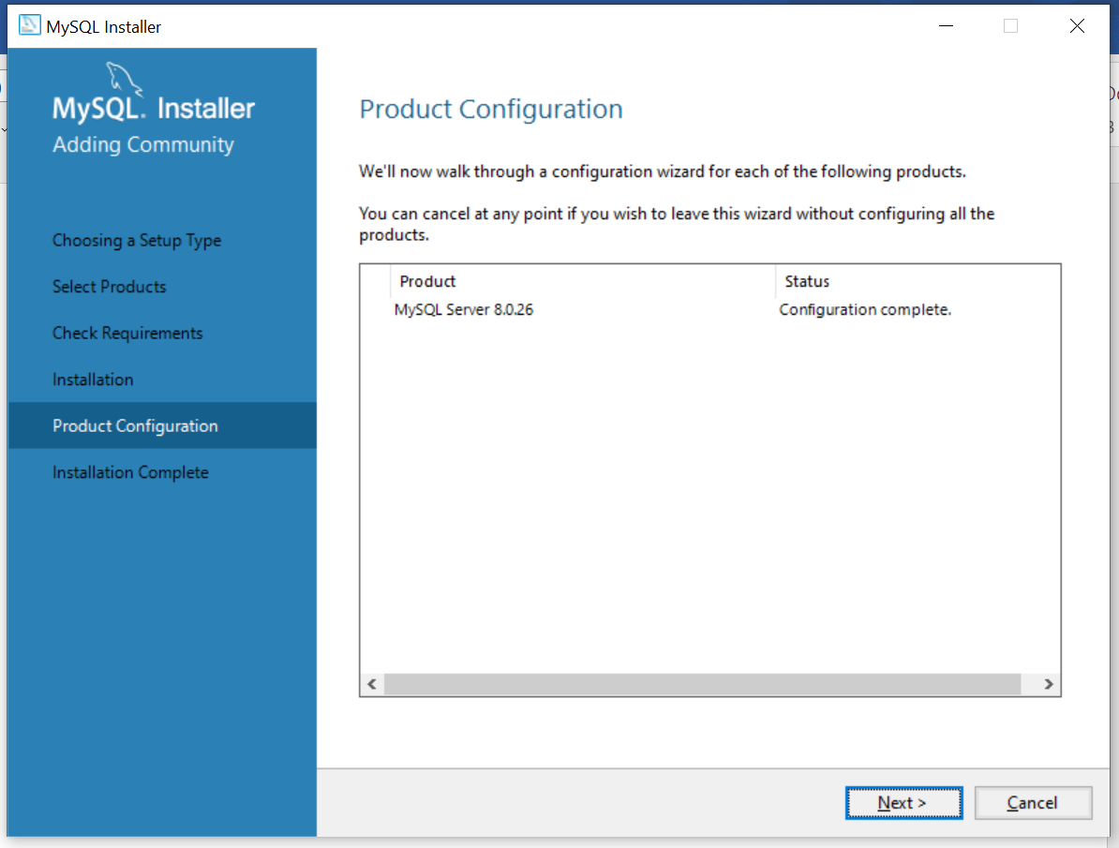

**Step 19-** Click on Next

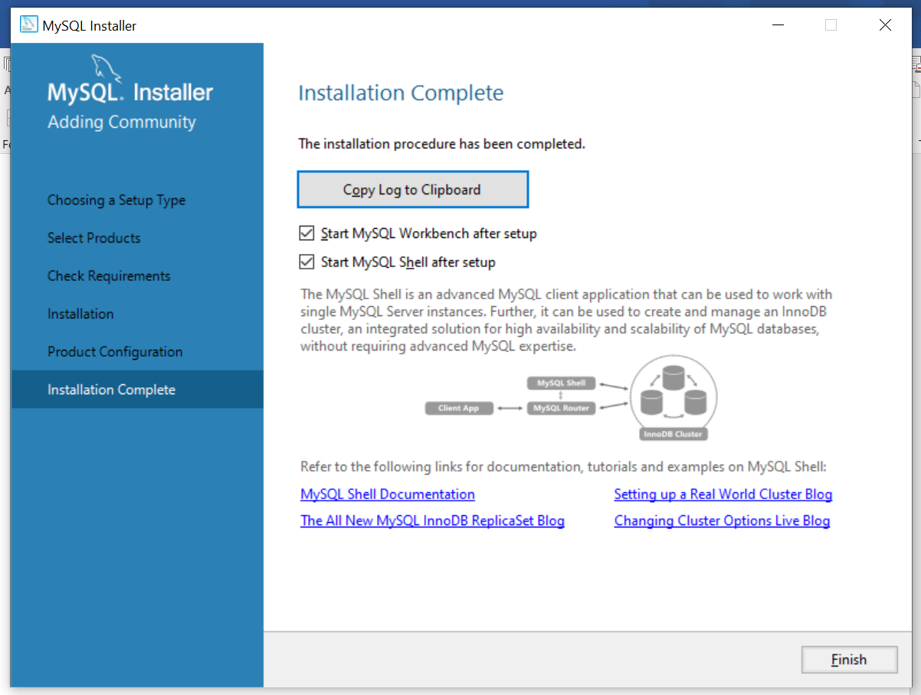

**Step 20-** Keep the default and click on Finish

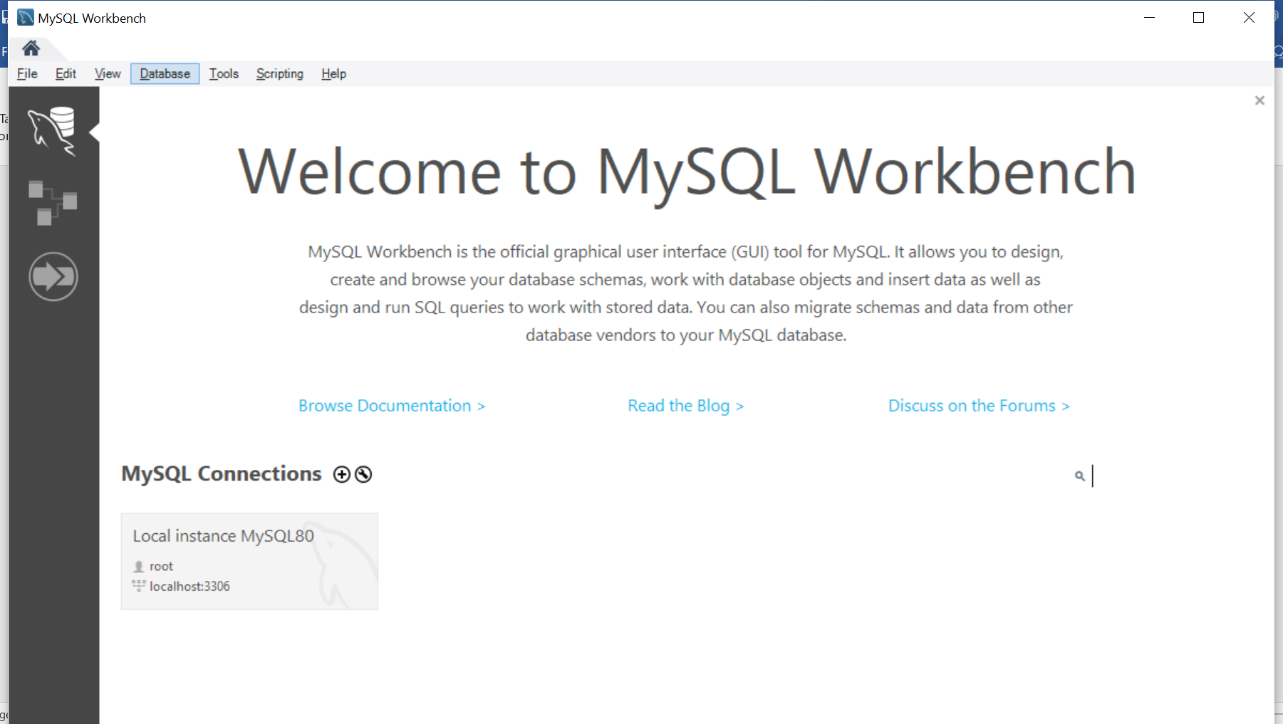

**Step 21-** We will get this interface click on the root

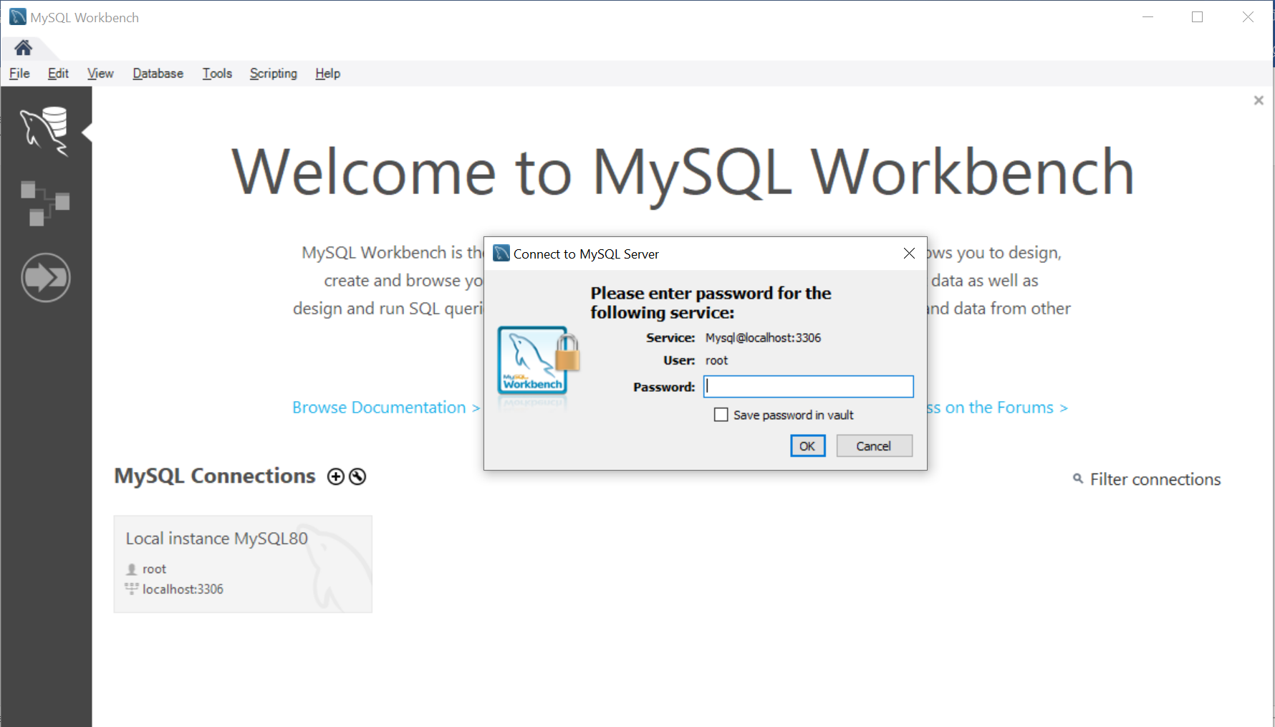

**Step 22-** Enter the password we entered before and click on ok

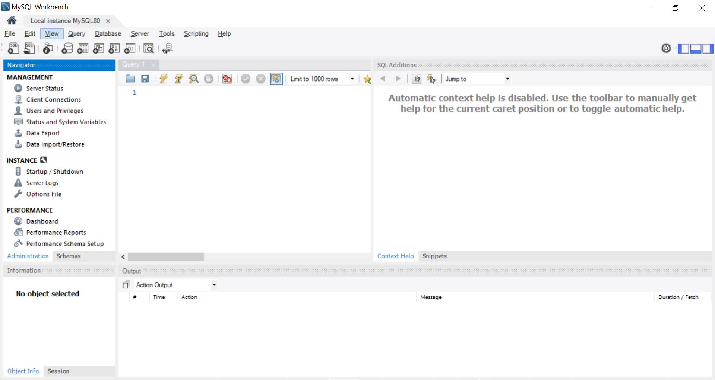

**Step 23-**We will see the interface like this, Now its Connected Successfully

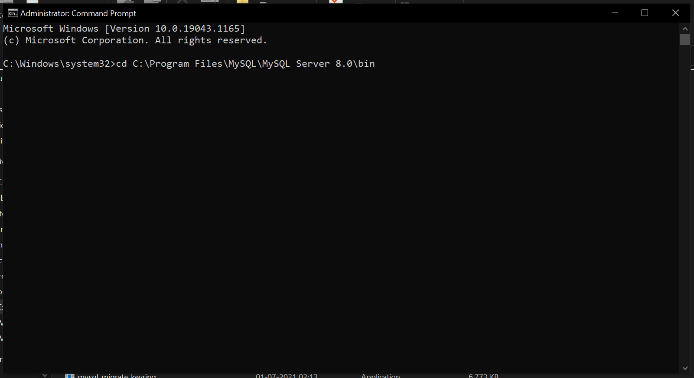

**Step 24-**Open the command prompt as administrator reach the path were we installed it(C:\Program Files\MySQL\MySQL Server 8.0\bin) copy it and come back to command prompt type cd(space) and paste it.

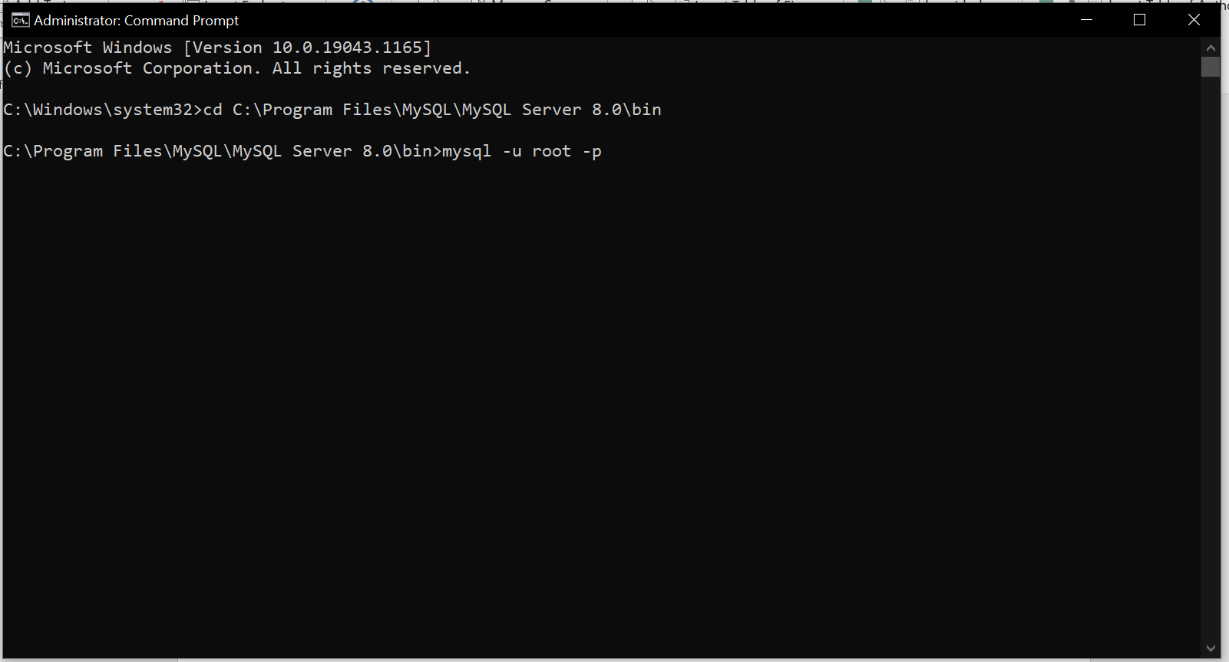

**Step 25-**Enter “mysql -u root -p”

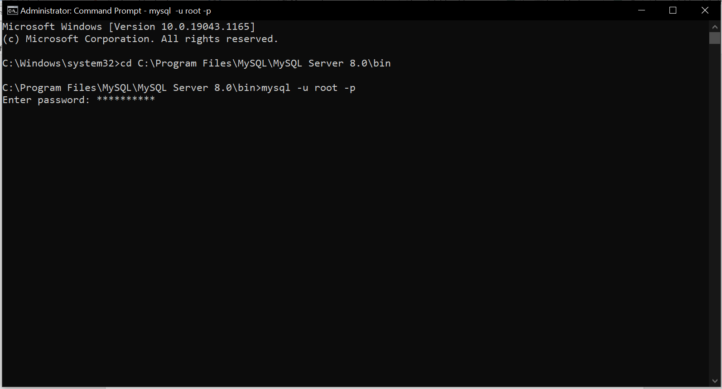

**Step 26-**Enter the password here

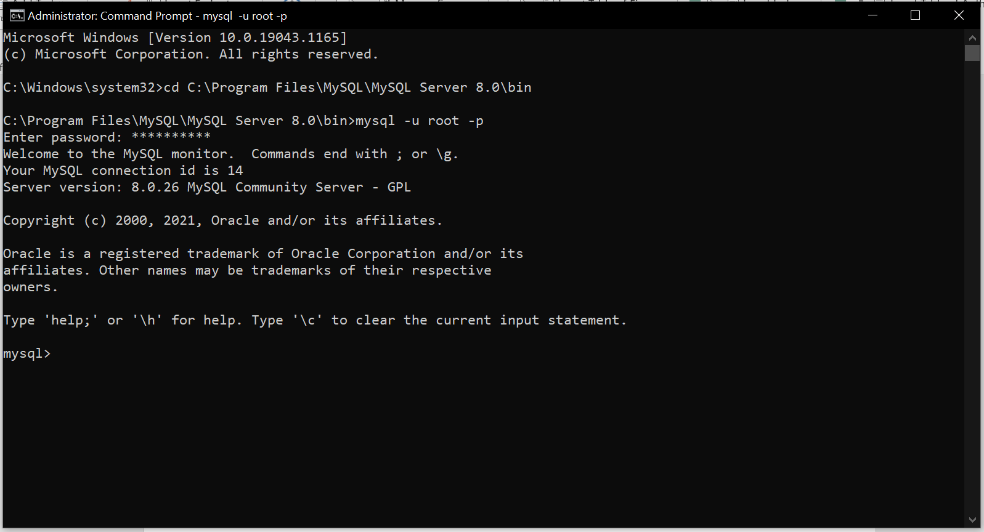

**Step 27-**As we can see we are started

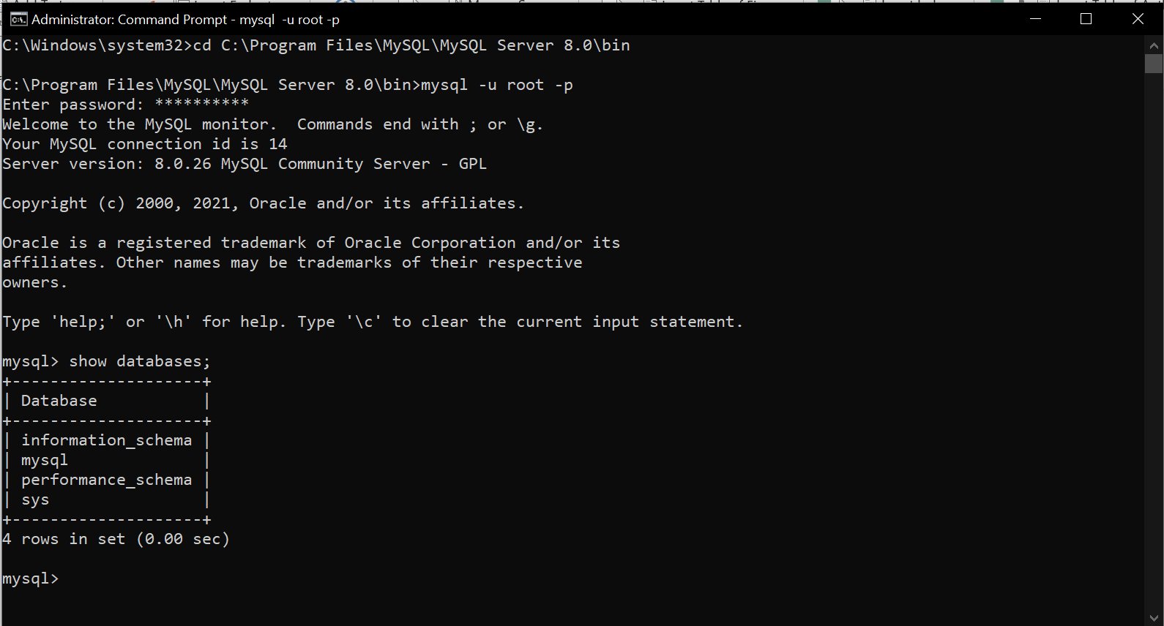

**Step 28-**By entering show databases;

It will show the default database that’s it.